04 Nights & 05 Days Shimla Tour

Day 01 Arrival Delhi

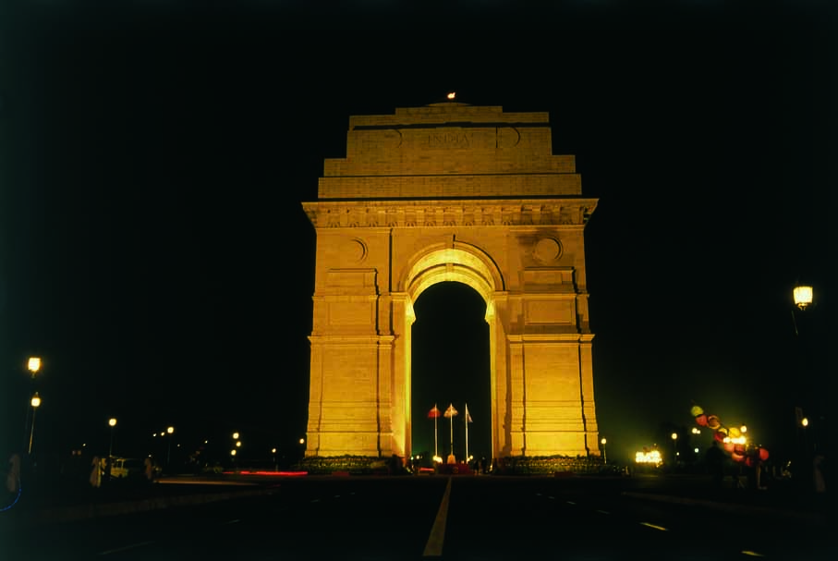
Arrive Delhi. You will be met by our representative at the airport & escorted till your check in at Hotel.

Delhi, the Empress of Indian cities has a fascinating history and a stimulating present. She has often been sacked and left naked and desolate. But she could not be despoiled of the incomparable situation that marks her for the metropolis of a Great Empire. The capital of India, Delhi has been the seat of power of a number of dynasties – the Rajputs, the Afghans, the Turks and the Mughals who continued their imperial line until the British. Scattered over are surviving ruins, remnants of mighty edifices, tombs of warriors and saints, which in an impressive sense of magnificence are memorials not of a single city but of supplanted nations.

Overnight at Hotel.

Day 02 Delhi – Kalka - Shimla

Morning transfer to railway station to board train for Kalka leaving Delhi at 740 Hrs & arrving Kalka at 1145 Hrs. Upon arrival connect tyrain to Shimla leaving Kalka at 1210 Hrs & arrving Shimla at 17Evening transfer to railway station to board overnight train to Kalka. leaving Delhi at 2125 Hrs & arriving Kal Hrs.

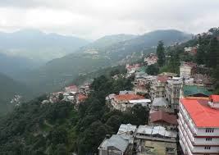
Shimla, the summer seat of the British Empire was discovered by Lt. Rose of the British Army in 1819. Patron goddess of the little village was Shamla Devi, and she gave her name to the settlement that sprang here. At an altitude of 2130 metres, Shimla straddles a Rhododendron and Conifer clad ridge, with settlements sloping down on both sides. A little steam engine chugs its way up forbidding inclines, trailing a leisurely handful of coaches. Shimla still retains its past historic splendours and is everything that it was in the good old days: wooden bungalows with gardens in which Gladioli and Hydrangea bloom; leisurely moments of horse riding, golf and cricket and fireside chats.
On arrival transfer and check in to hotel..

You will be met by our representative at Shimla railway station & transfer to Hotel.

Balance day free at Leisure

Overnight at Hotel.

Day 03 In Shimla

Morning after breakfast proceed for full day city tour of Shimla visiting Indian Institute Of Advanced Studies, Sankat Mochan Temple and Jakhu Temple. Evening free to stroll in the famous shopping place of Shimla town - The Mall & The Ridge.
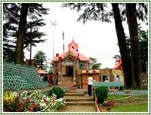
Jhaku Temple : Best seen in the soft morning sunlight. This temple is on an incline. It takes about 45 minutes of walking from Scandal Point to get here. Dedicated to the monkey God Hanuman, there are a few real monkeys too many out here, but leave them alone and don't eat food around them, and you will be able to enjoy a spectacular view of the snow-bound mountains. The temple is believed to have the foot prints of Hanuman, and is located at a height of 2455 m and is the highest point of Simla Ridge.

Viceregal Lodge : Housed in the Gothic splendor of the Viceregal Lodge is the Indian Institute of Advanced studies, India's premier academy for higher research.

Jakhoo Hill : The steep climb to Jakhoo Hill, Shimla's highest point, is rewarding for superb views of the town and its surroundings. At the top is an old Hanuman temple.

Overnight at hotel

Day 04 In Shimla

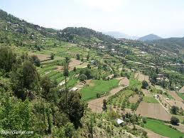
Morning after breakfast proceed to visit Kufri & Chail.

Kufri : With its glorious views of forested slopes and tall ranges iced in a covering of perpetual snow, Kufri will keep you spellbound by its enchanting beauty. Also known as "The Switzerland of the East", the refreshing atmosphere with its exotic flora and fauna will inspire and rejuvenate you.

Balance day free at leisure.

Overnight at hotel.

Day 05 Shimla – Kalka - Delhi (By Train)
Leave Delhi

Morning in time transfer to railway station to board train to Kalka, leaving Shimla at 1030 Hrs & arriving Kalka at 1610 Hrs. On arrival in Kalka board train to Delhi , Leaving Kalka at 1745 Hrs & arriving Delhi at 2155 Hrs.

On arrival in time transfer to airport to connect flight for onward destination.

